Start server and generates data then creates temptable and generates data into it using the last code.

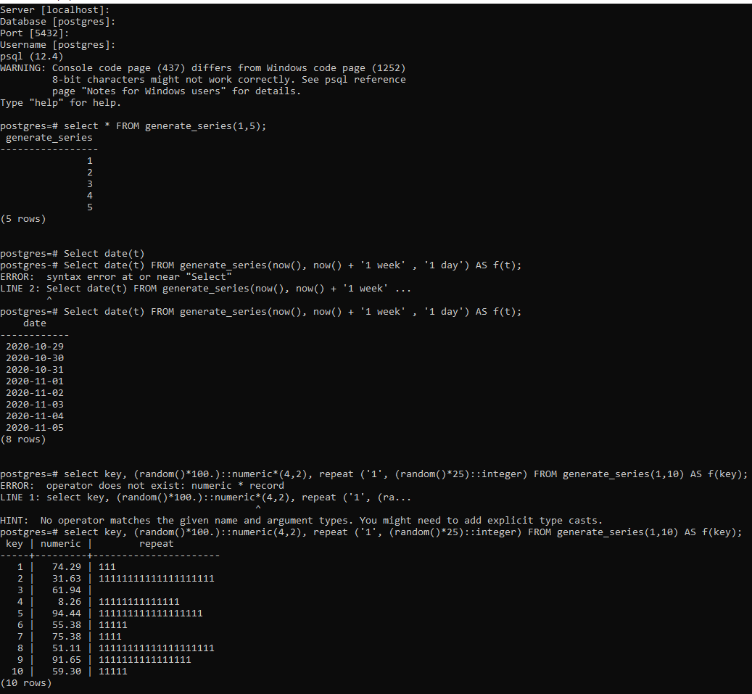

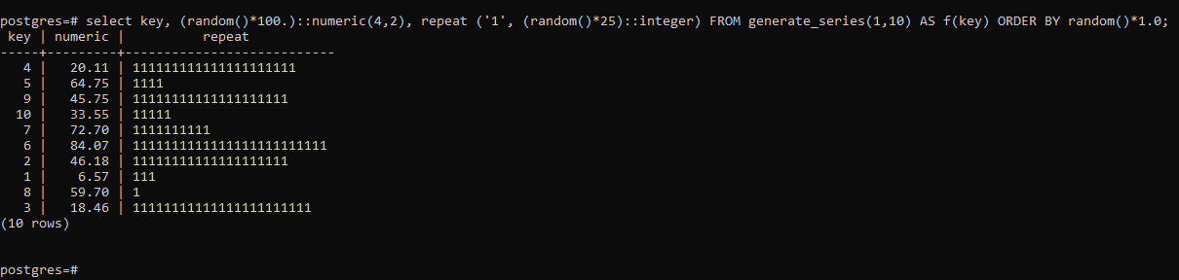

2. runs different commands against the test data.

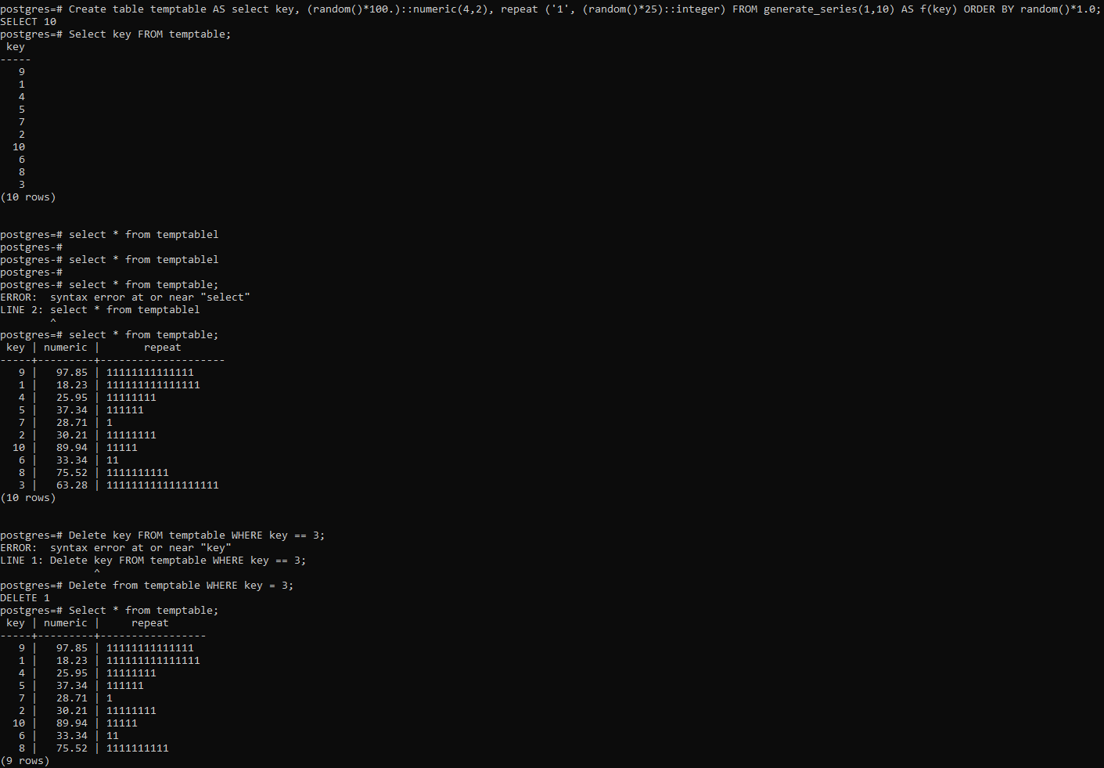

3 and 4: uses DATANAMIC to generate random fields into the temptable then uses some commands to delete the random data.

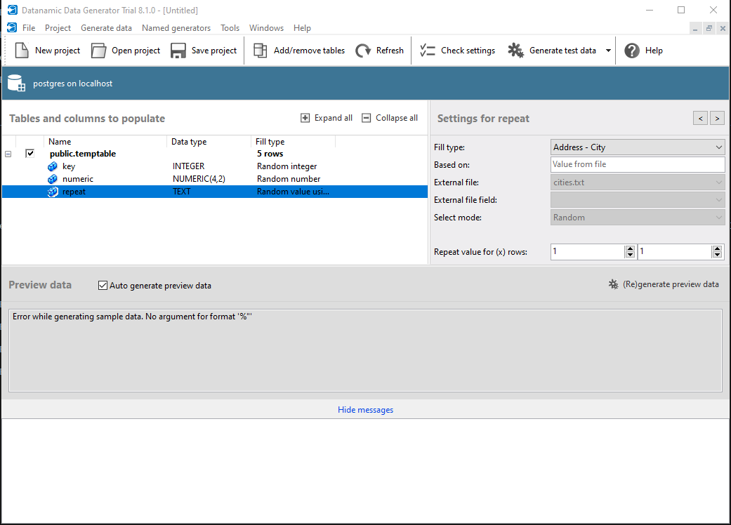

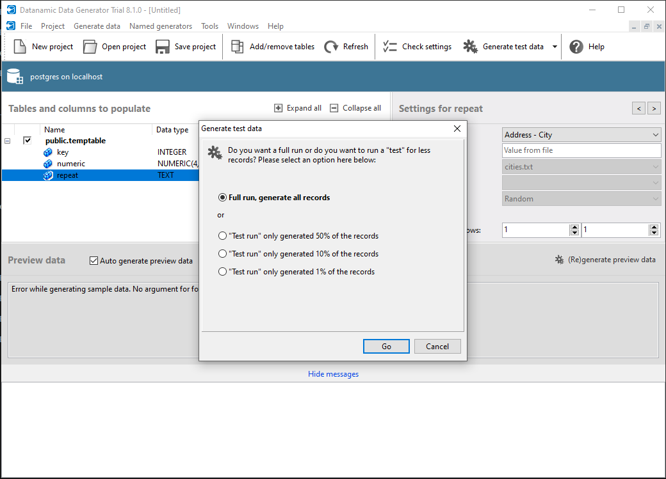

results: 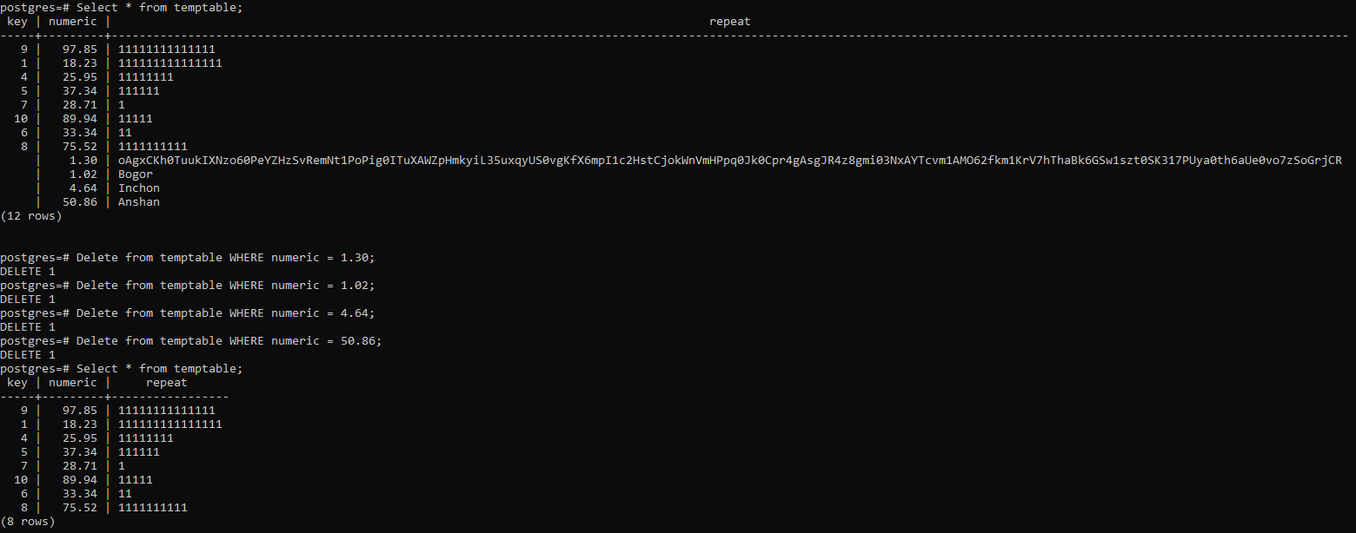

5: samples temptable and returns a count using the BERNOULLI command at 50%.

